Statistics CA 1
  - D00255640

Part A
For Part A, I had to load in the file that I needed to complete this project. The first step I did was set my working directory so I could easily find where my project was. Then, I had to load in the ‘MASS’ library and select the ‘Melanoma’ dataset.
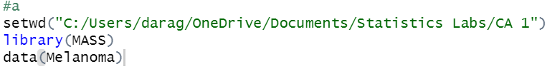

Part B
For Part B, I had to describe the data from the Melanoma dataset. This was done by finding the number of rows and columns in the data. This showed me the number of entries and variables in the dataset.
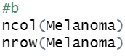

Part C
For Part C, I had to find what type of variables are in the dataset. I found that there was six integer variables and one float as it consists of decimal values.
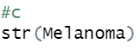

Part D
For Part D, I had to make suitable univariate graphs for each variable. I done this by making a histogram of the age variable, a bar plot of the sex variable, a histogram for the thickness variable, and a bar plot for the status variable. Through doing this I found that most people with Melanoma are between forty and sixty, more females have it than males, the thickness is mostly very small, below five millimetres, and most people in this dataset are still alive who have Melanoma.
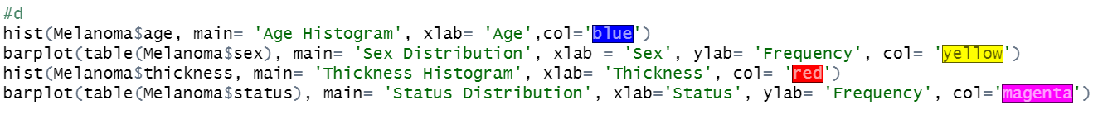
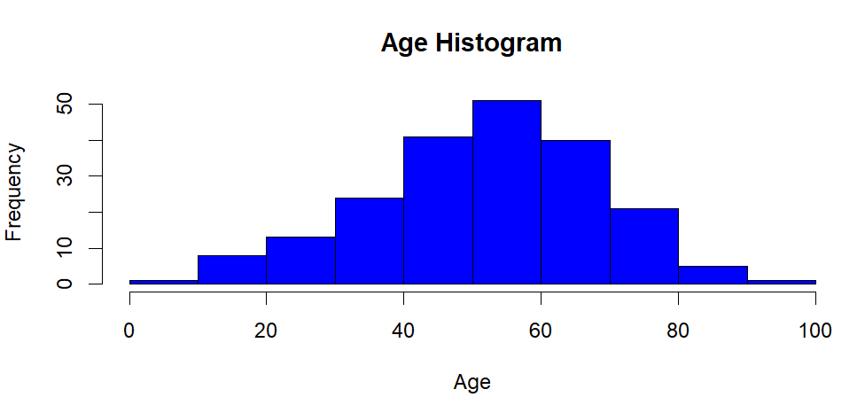
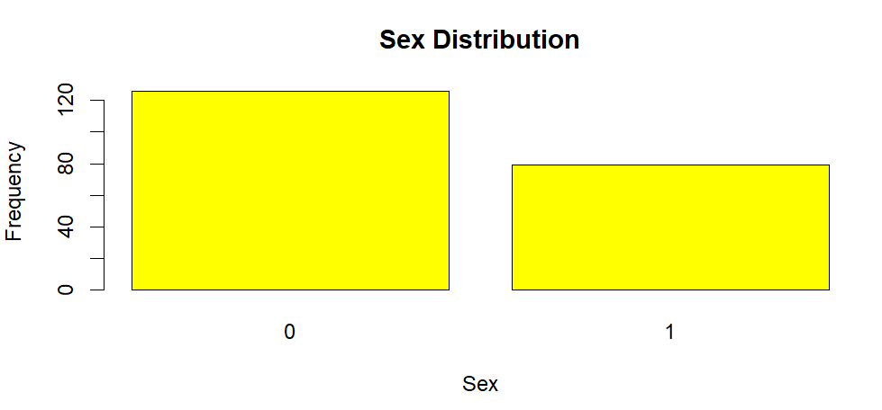
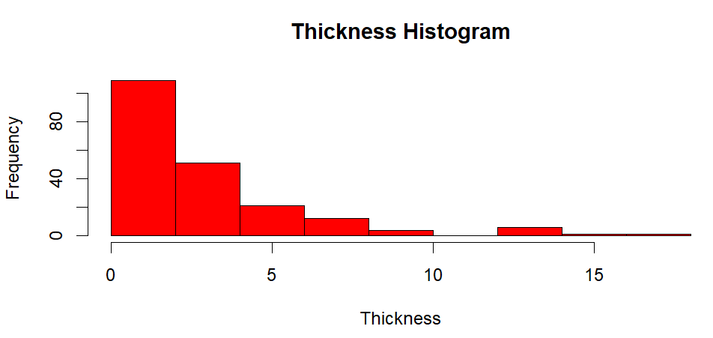
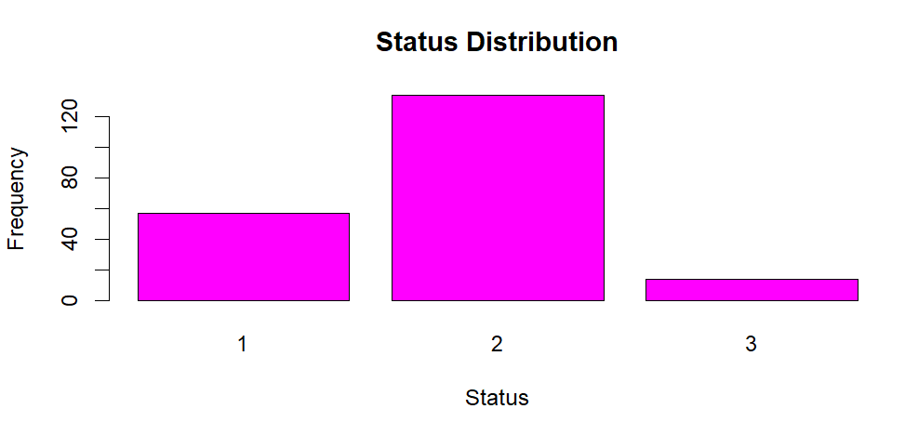

Part E
For Part E, I had to find the descriptive statistics for each of the numerical variables. I found the mean and median to be 52.46 and 54 for the age variable, the mean and median both to be 1970 for the year variable, the mean of 0.439 and median of 0 for the ulcer variable, and median of 1.94 with mean of 2.92 for the thickness variable.
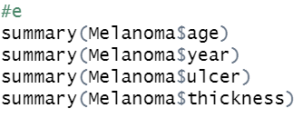

Part F
For Part F, I had to create suitable bivariate plots to find relationships between the variables. I made a scatterplot for the age and thickness variables, and I found that there is not much of a relationship between them. I used a table to show the sex and status of the people with Melanoma. I used a box plot with the age and status variables, and I discovered that the ages are a lot more variate for people who had Melanoma that died unrelated to the disease and people still alive compared to the people who died because of the disease. I used a boxplot to show the age by year variables. I learned that the ages of the people were mostly between 30 and 60 years old from 1965 until 1973.
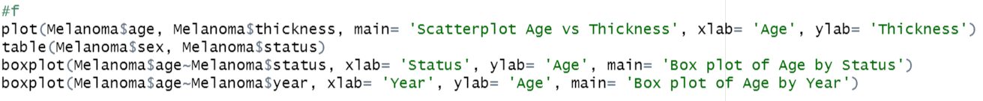
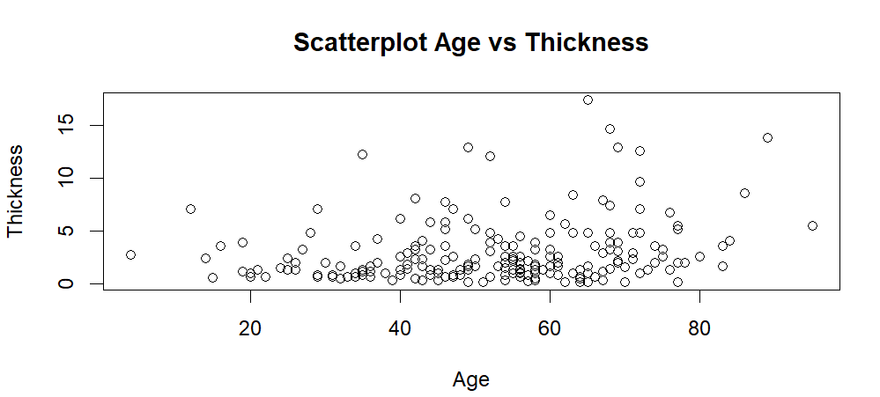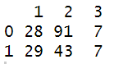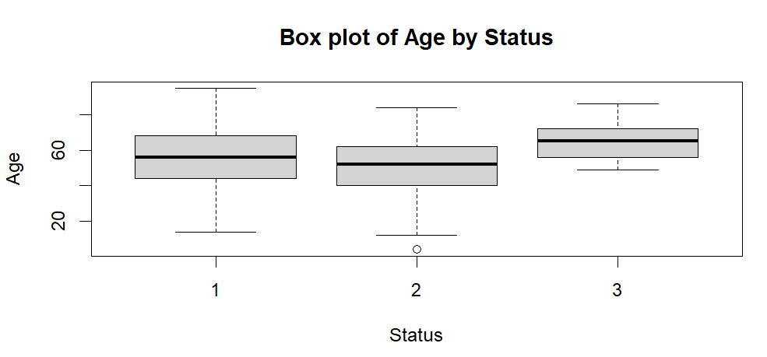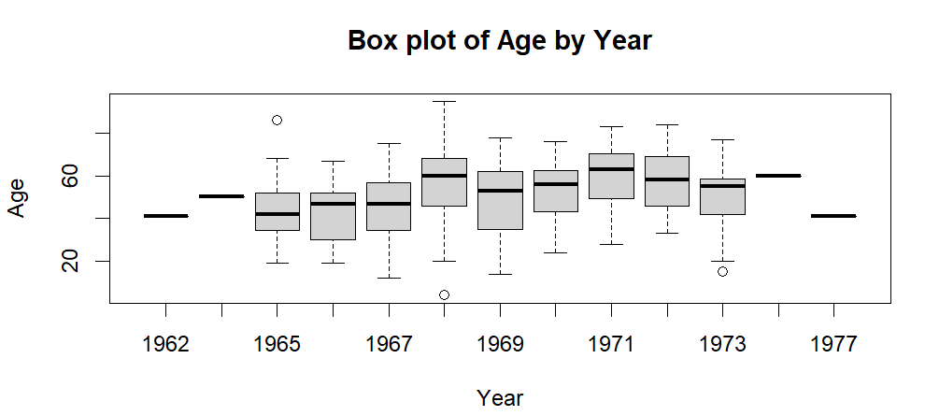

Part G
For Part G, I had to make multivariate plots. I used the library ‘ggplot2’ to graph the functions. I used the age, thickness, and ulcer functions to show on the graphs. I done two different types of graphs.
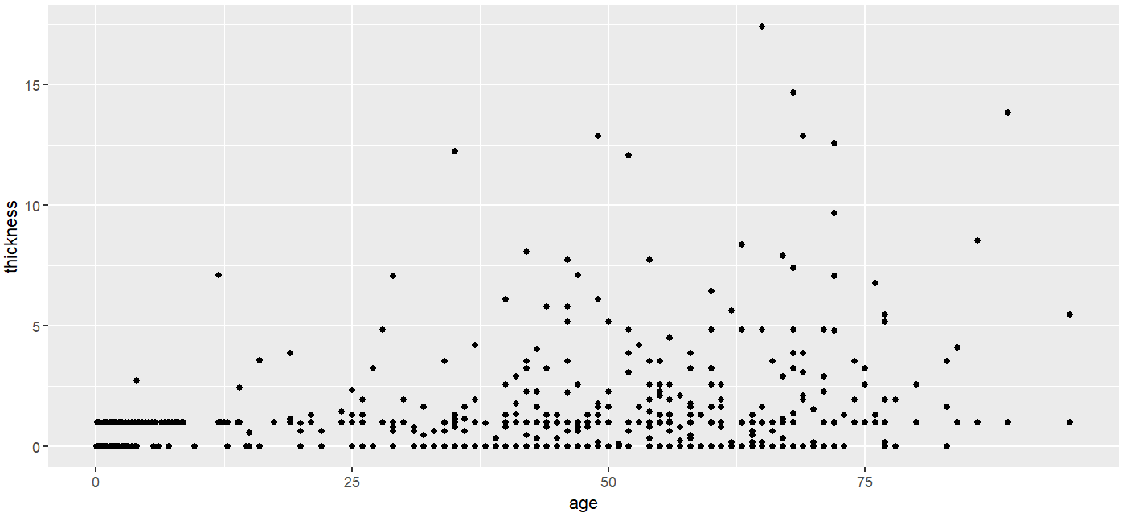
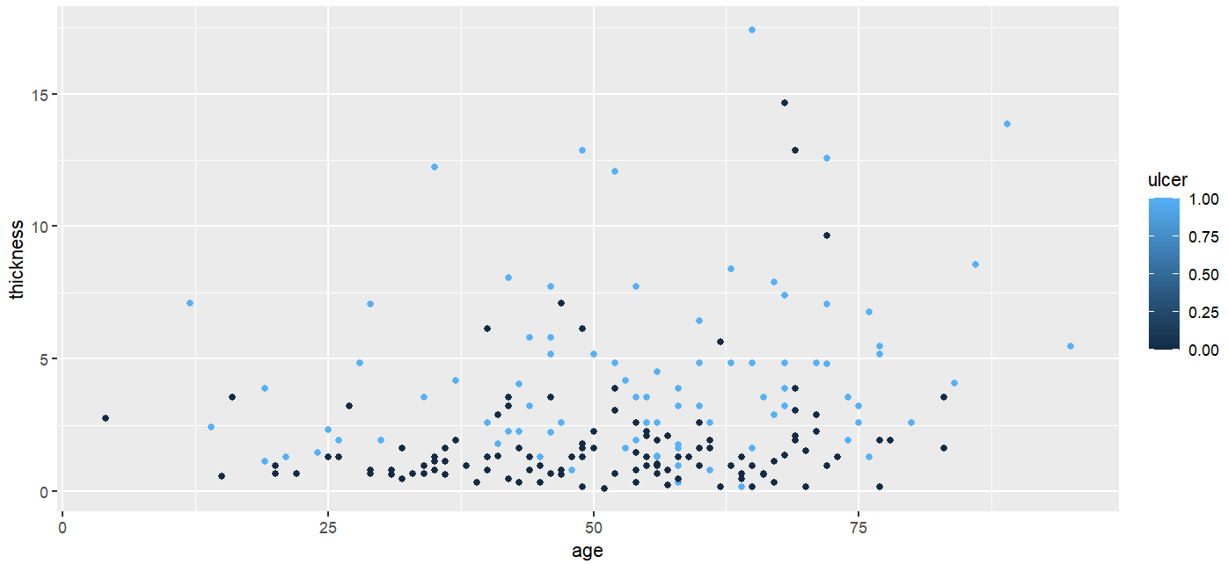

Part H
For this part, I had to use the cor function to calculate the correlation between each of the numerical variables. I done this for every variable to try and find a relationship between any of them.
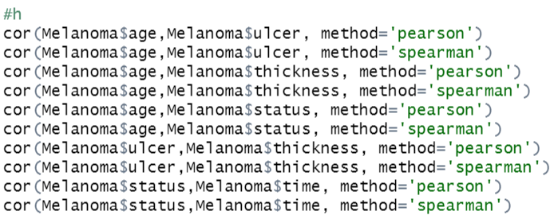

Part I
For Part I, I used the cor.test function to test the strongest correlation that I found from doing Part H. From this I found that there wasn’t much of a relationship between thickness and ulcer when I assumed there would be.
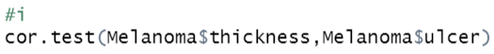
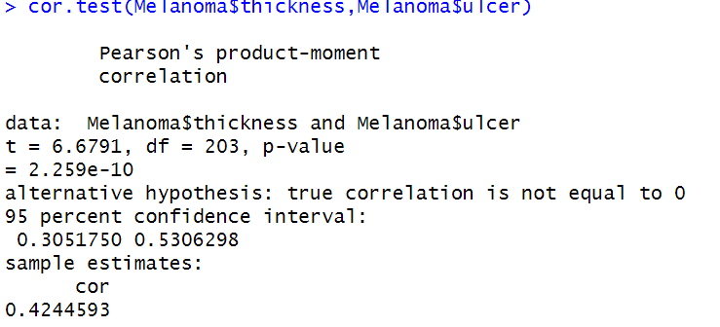

Part J
For Part J, I used the lm function to make a suitable linear model. This gave me a result that I used with the summary() variable to calculate the linear model. 